Stata Homework Relevant Output and Explanations

**Part a)**

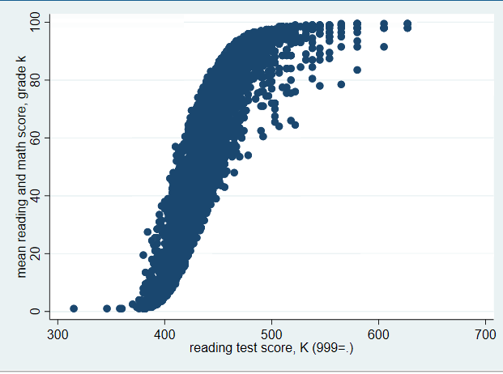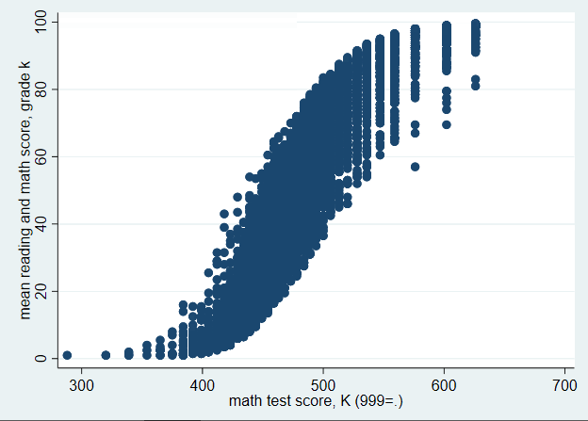

These graphs show that the raw scores and the mean scores are positively correlated with each other.

The mean scores of reading and math is marked as “mnscorek”.

The raw scores are marked as “readk” and “mathk”.

We saved the images with the **graph export** command

We created the scatter plots with the **scatter** command

**Part b)**

We created the **freelunch** variable with the **gen** command.

* If the socioeconomic status of a student was a 1, they would get a free lunch (==1)
* However, if the socioeconomic status of a student was a 0, they would not get a free lunch
  + So, we had to use the **replace** command to modify the data

Based off of the variables in the given dataset, a white student was equal to 1 and an Asian student was equal to 3. We used the **race** variable

* To distinguish these kids, we created the variable **whiteorasian**
  + We used the gen command to create it

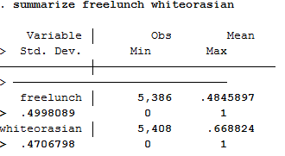

To summarize these new variables with the **summarize** command, we found the mean and the standard deviation.

**Part c)**

For this part, we had to add white teachers and Asian teachers to a new variable

We generated a new variable **Twhiteorasian** to take data away from the **tracek** variable already given

* The goal of this was to branch off two values (white and Asian) from **tracek** to solve the problem

The second variable was given in the dataset, **totexpk**

* This variable was the total experience of the teachers

The graph below summarizes the mean and the standard deviation of the race of the teachers and how long they have been teaching

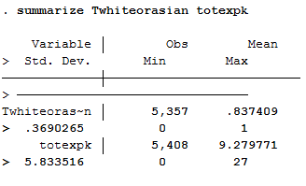

The chart indicates that most of the teachers are either white or Asian. It says so because the mean is closest to 1 and not 0, whereas those teachers are not white or Asian

The chart also indicates that the total experience of these teachers is 9.3 years. The minimum is 0 years and the max is 27 years.

**Part d)**

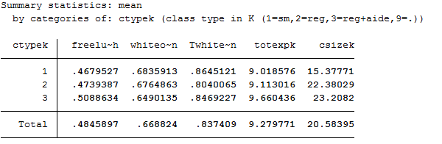

The chart from the **tabstat** command indicates the means from the variables

The variables that go from 0 to 1 are **freelunch, whiteorasian, and Twhiteorasian.**

* Based off of the chart
  + The majority of the kids do not get a free lunch
  + the majority of students are white or Asian
  + The majority of the teachers are white or Asian
  + The teachers have a total experience teaching of about 9 years
* Class size
  + Small class size average: 15.3771
  + Regular class size average: 22.38029
  + Regular class size plus aid average: 23.2082

**\*Yes! The means of the variables are randomly (evenly) distributed across the class types.**

**Ctypek**

1. Small class size
2. Regular class size
3. Regular class size plus aid